Geometry: Unit 8, Lesson 4

- Given the following description, which quadrilateral best fits the description provided?
Quadrilateral with two pairs of adjacent sides congruent and whose diagonals are perpendicular.

Kite

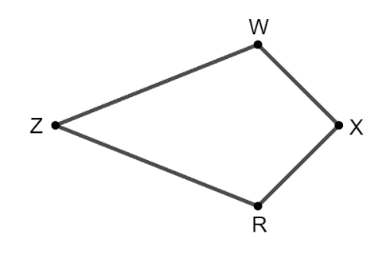
- Kite $ZWXR$ where $ZW=15x-8$, $WX=8x+2$, and $RX=10x-8$ is shown. What is an equation that can be used to find the value of $x$?

$$8x+2=10x-8$$

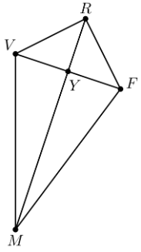
- Kite $VRFM$ with diagonals $\overline{RM}$ and $\overline{VF}$ intersecting at point $Y$ and $∠RVM≅∠RFM$ is shown. Is the statement $\overline{VM}≅\overline{FM}$ true?

Yes

